STAT-506: SAS Project

Description: The data worked with consists of my daily and workout health history captured from my wearable.

**Topics: 6,8,3,12,15,21,18,20,25,27,14,9**

/* 6. Read Excel spreadsheets into SAS using:

a) LIBNAME statement to read multiple pages of a excel file

b) Proc IMPORT (generate the code)

c) Proc EXPORT (generate the code)

d) LIBNAME statement with CLEAR option

*/

libname health excel "W:\My Documents\My SAS Files\Microsoft_Health_20150418_20150831.xls"; /* 6a */

PROC IMPORT OUT= WORK.Activity /* 6b */

DATAFILE= "W:\My Documents\My SAS Files\Microsoft_Health_201

50418_20150831.xls"

DBMS=EXCEL REPLACE;

RANGE="'Activity summary$'";

GETNAMES=YES;

MIXED=NO;

SCANTEXT=YES;

USEDATE=YES;

SCANTIME=YES;

RUN;

PROC EXPORT DATA= WORK.ACTIVITY /* 6c */

OUTFILE= "W:\My Documents\SAS Project\exported.xls"

DBMS=EXCEL REPLACE;

SHEET="activity";

RUN;

libname health clear; /* 6d */

__________________________________________________________________________________________________

/* 8. Use the following to read in a data set that has FORMATTED data:

a) INFILE

b) INPUT using at least 4 INFORMATs

c) FORMAT statement to re-format at least 2 variables

d) Proc PRINT

*/

libname health "W:\My Documents\SAS Project";

data health.activity; /* 8a */

length Event_Type $10. Cardio_Benefit $12. Sleep_Restoration $8. Sleep_Auto_Detect $6. ;

infile "W:\My Documents\SAS Project\Activity.csv" dlm=',' dsd missover;

input Input_Date :mmddyy9. Start_Time :time. Event_Type Duration_Seconds Seconds_Paused Calories_Burned

Calories_Burned_Carbs Calories_Burned_Fats HR_Lowest HR_Peak HR_Average

UV_Exposure_Minutes Total_Kilometers_Moved Cardio_Benefit Minutes_Under_50_HR

Minutes_In_HRZ_Very_Light_50_60 Minutes_In_HRZ_Light_60_70

Minutes_In_HRZ_Moderate_70_80 Minutes_In_HRZ_Hard_80_90 Minutes_In_HRZ_Very_Hard_90_Plus

HR_Finish HR_Recovery_Rate_1_Min HR_Recovery_Rate_2_Min Recovery_Time_Seconds Bike_Average_KPH

Bike_Max_KPH Elevation_Highest_Meters Elevation_Lowest_Meters Elevation_Gain_Meters

Elevation_Loss_Meters Wake_Up_Time :MDYAMPM20.2 Seconds_Awake Seconds_Asleep_Total Seconds_Asleep_Restful

Seconds_Asleep_Light Wake_Ups Seconds_to_Fall_Asleep Sleep_Efficiency Sleep_Restoration

Sleep_HR_Resting Sleep_Auto_Detect GW_Plan_Name GW_Reps_Performed GW_Rounds_Performed

Golf_Course_Name Golf_Course_Par Golf_Total_Score Golf_Par_or_Better Golf_Pace_of_Play_Minutes

Golf_Longest_Drive_Yards;

run;

data health.activity; /* 8b */

length Event_Type $10. Cardio_Benefit $12. Sleep_Restoration $8. Sleep_Auto_Detect $6. ;

infile "W:\My Documents\SAS Project\Activity.csv" dlm=',' dsd missover;

input Input_Date :mmddyy9. Start_Time :time. Event_Type :$10. Duration_Seconds :7. Seconds_Paused Calories_Burned

Calories_Burned_Carbs Calories_Burned_Fats HR_Lowest HR_Peak HR_Average

UV_Exposure_Minutes Total_Kilometers_Moved Cardio_Benefit Minutes_Under_50_HR

Minutes_In_HRZ_Very_Light_50_60 Minutes_In_HRZ_Light_60_70

Minutes_In_HRZ_Moderate_70_80 Minutes_In_HRZ_Hard_80_90 Minutes_In_HRZ_Very_Hard_90_Plus

HR_Finish HR_Recovery_Rate_1_Min HR_Recovery_Rate_2_Min Recovery_Time_Seconds Bike_Average_KPH

Bike_Max_KPH Elevation_Highest_Meters Elevation_Lowest_Meters Elevation_Gain_Meters

Elevation_Loss_Meters Wake_Up_Time :MDYAMPM20.2 Seconds_Awake Seconds_Asleep_Total Seconds_Asleep_Restful

Seconds_Asleep_Light Wake_Ups Seconds_to_Fall_Asleep Sleep_Efficiency Sleep_Restoration

Sleep_HR_Resting Sleep_Auto_Detect GW_Plan_Name GW_Reps_Performed GW_Rounds_Performed

Golf_Course_Name Golf_Course_Par Golf_Total_Score Golf_Par_or_Better Golf_Pace_of_Play_Minutes

Golf_Longest_Drive_Yards;

run;

data health.activity; /* 8c */

length Event_Type $10. Cardio_Benefit $12. Sleep_Restoration $8. Sleep_Auto_Detect $6. ;

infile "W:\My Documents\SAS Project\Activity.csv" dlm=',' dsd missover;

input Input_Date :mmddyy9. Start_Time :time. Event_Type :$10. Duration_Seconds :7. Seconds_Paused Calories_Burned

Calories_Burned_Carbs Calories_Burned_Fats HR_Lowest HR_Peak HR_Average

UV_Exposure_Minutes Total_Kilometers_Moved Cardio_Benefit Minutes_Under_50_HR

Minutes_In_HRZ_Very_Light_50_60 Minutes_In_HRZ_Light_60_70

Minutes_In_HRZ_Moderate_70_80 Minutes_In_HRZ_Hard_80_90 Minutes_In_HRZ_Very_Hard_90_Plus

HR_Finish HR_Recovery_Rate_1_Min HR_Recovery_Rate_2_Min Recovery_Time_Seconds Bike_Average_KPH

Bike_Max_KPH Elevation_Highest_Meters Elevation_Lowest_Meters Elevation_Gain_Meters

Elevation_Loss_Meters Wake_Up_Time :MDYAMPM20.2 Seconds_Awake Seconds_Asleep_Total Seconds_Asleep_Restful

Seconds_Asleep_Light Wake_Ups Seconds_to_Fall_Asleep Sleep_Efficiency Sleep_Restoration

Sleep_HR_Resting Sleep_Auto_Detect GW_Plan_Name GW_Reps_Performed GW_Rounds_Performed

Golf_Course_Name Golf_Course_Par Golf_Total_Score Golf_Par_or_Better Golf_Pace_of_Play_Minutes

Golf_Longest_Drive_Yards;

Sleep_Efficiency = Sleep_Efficiency/100;

format Input_Date date9. Sleep_Efficiency percent8.2 ;

run;

proc contents data=health.activity;

run;

proc print data=health.activity; /* 8d */

format Start_Time hhmm8.2 Wake_Up_Time MDYAMPM20.2;

run;

/* 3. Print SAS data set(s) using:

a) Proc PRINT

b) SPLIT= option

c) TITLE

d) FOOTNOTE

*/

PROC IMPORT OUT= HEALTH.Daily

DATAFILE= "W:\My Documents\SAS Project\Microsoft_Health_2015

0418_20150831.xls"

DBMS=EXCEL REPLACE;

RANGE="'Daily summary$'";

GETNAMES=YES;

MIXED=NO;

SCANTEXT=YES;

USEDATE=YES;

SCANTIME=YES;

RUN;

proc print data=health.Daily ; /* 3a */

run;

proc print data=health.Daily Split="_"; /* 3b */

run;

title "Sneha's Daily Activity"; /* 3c */

proc print data=health.Daily Split="_";

run;

title ;

footnote "Data from Sneha's Health Band"; /* 3d */

proc print data=health.Daily Split="_";

run;

/* 12. Merge two or more data sets—at least two different merges must be done

a) One must have non-matches

(1) Use IN= options with a IF conditional statement

(2) Direct output to 2 different datasets (matches and non-matches)

b) One must use the options below

(1) RENAME=

(2) DROP=/KEEP= options

*/

/* both datasets are already sorted by Input_Date */

data matches nonmatches(drop=Calories_Burned HR_Peak) ; /* 12a */

merge health.activity (in=a) health.daily (rename= (Date=Input_Date)in=d) ;

by Input_Date;

if (a=1 and d=1 ) then output matches;

else output nonmatches;

keep Input_Date Calories_Burned HR_Peak;

run;

data merged (keep= Input_Date Duration_Seconds Calories_Burned Total_Kilometers_Moved ); /* 12b */

merge health.activity (rename=(Seconds_Paused=Pause_Time_Sec) in=a) health.daily (rename= (Date=Input_Date)in=d) ;

by Input_Date;

run;

/* 15. Demonstrate the following

a) Use of RETAIN

b) Sum Statement (variable + expression;)

c) Use of FIRST. and LAST.

d) Proc SORT

*/

data total; /* 15a */

set health.activity;

retain Total_Calories_Burned 0;

Total_Calories_Burned = Total_Calories_Burned + Calories_Burned;

keep Input_Date Calories_Burned Total_Calories_Burned;

run;

data total_to_date; /* 15b */

set health.activity;

Total_Calories_Burned + Calories_Burned;

keep Input_Date Calories_Burned Total_Calories_Burned;

run;

proc sort data=health.activity /* 15d */

out=activity;

by Event_Type Cardio_Benefit;

run;

data aggregate; /* 15c */

set activity;

by Event_Type Cardio_Benefit;

if first.Event_Type then Calorie_Count = 0;

else Calorie_Count + Calories_Burned;

if last.Cardio_Benefit then output;

run;

/* 21. Converting Variable Type

a) Character to Numeric

b) Numeric to Character

c) Demonstrate automatic conversion (need log here)

d) Proc CONTENTS showing the original variable type

*/

data health.conversion; /* 21b */

set health.daily (rename=(Steps=numSteps Total_Kilometers_Moved=numTLM));

Steps = put(numSteps,5.);

Total_Kilometers_Moved = put(numTLM, 10.2);

keep Date Steps Total_Kilometers_Moved;

run;

data health.toNum (drop=charSteps charTLM); /* 21a */

set health.conversion (rename=(Steps=charSteps Total_Kilometers_Moved=charTLM));

Steps=input(charSteps,5.);

Total_Kilometers_Moved=input(charTLM,10.2);

run;

data health.autoconversion; /* 21c */

set health.conversion;

Meters_Moved = Total_Kilometers_Moved * 1000;

run;

/* Log */

/*

14

15 data health.autoconversion; /* 21c */

16 set health.conversion;

17 Meters_Moved = Total_Kilometers_Moved * 1000;

18 run;

NOTE: Character values have been converted to numeric values at the places given by:

(Line):(Column).

17:20

NOTE: There were 136 observations read from the data set HEALTH.CONVERSION.

NOTE: The data set HEALTH.AUTOCONVERSION has 136 observations and 4 variables.

NOTE: DATA statement used (Total process time):

real time 0.22 seconds

cpu time 0.00 seconds

*/

proc contents data=health.conversion; /* 21d */

run;

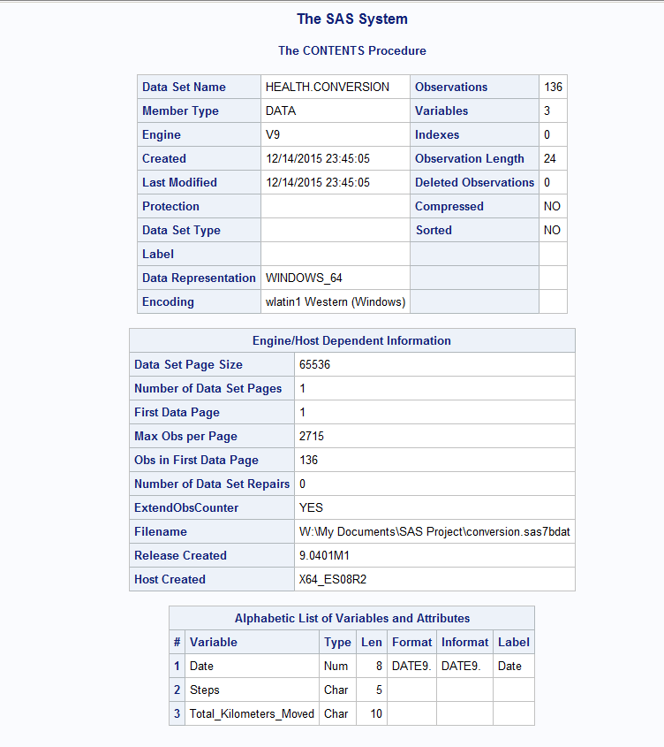

/* 18. Use the following fuctions

a) SUBSTR

b) LENGTH

c) SCAN

d) PROPCASE

e) One of (RIGHT, LEFT, UPCASE, LOWCASE, CHAR)

f) CATX (or CAT, CATS, CATT)

*/

data health.functions;

set health.activity;

length Status $40.;

if (Cardio_Benefit = ' ') then Status = "Lazy Sneha did not workout today!";

else do;

select (substr(Cardio_Benefit,1,1)); /* 18a */

when ('M') Status = "Sneha worked out pretty well";

when ('L') Status = "Sneha can push herself to do better";

otherwise Status = "Error";

end;

end;

keep Input_Date Cardio_Benefit Status;

run;

data health.functions;

set health.activity;

length Emoticon $11.;

if (length(Event_Type)>5 or length(Event_Type)<4) then Emoticon = "Thumbs Up"; /* 18b */

else Emoticon = "Thumbs Down";

keep Event_Type Emoticon;

run;

data health.functions2;

set health.functions;

UporDown = scan(Emoticon,2); /* 18c */

Keep Event_Type UporDown;

run;

data health.functions3;

set health.functions;

low = lowcase(Event_Type); /* 18d */

proper = propcase(low); /* 18e */

Keep Event_Type low proper;

run;

data health.functions4;

set health.activity;

Description = catx("-",Event_Type,Cardio_Benefit); /* 18f */

keep Input_Date Description;

run;

/* 20. Use the following functions

a) ROUND

b) One of (CEIL, FLOOR, INT)

c) One of (SUM, MEAN)

d) One of (MIN, MAX, N)

e) One of (NMISS, CMISS)

*/

data health.math;

set health.daily;

Kilometers_Moved = round(Total_Kilometers_Moved,0.1); /* 20a */

keep Date Kilometers_Moved;

run;

data health.math2;

set health.daily;

Max_Kilometers_Moved = ceil(Total_Kilometers_Moved); /* 20b */

keep Date Max_Kilometers_Moved;

run;

data health.math3;

set health.activity;

total_calories_burned = sum(Calories_Burned_Carbs,Calories_Burned_Fats); /* 20c */

average_calories_burned = mean(Calories_Burned_Carbs,Calories_Burned_Fats);

keep Input_Date total_calories_burned average_calories_burned;

run;

data health.math4;

set health.activity;

min_heart_rate= min(HR_Lowest,HR_Average,HR_Finish); /* 20d */

keep Input_Date min_heart_rate;

run;

data health.math5;

set health.activity;

number_of_missing_hr = nmiss (HR_Lowest,HR_peak,HR_Average,HR_Finish); /* 20e */

keep Input_Date number_of_missing_hr;

run;

/* 25. Demonstrate the following:

a) OPTIONS SYMBOLGEN

b) %put

c) %let: Create and use at least three user macro variables

d) Use at least three automatic macro Variables

e) %SYMDEL

*/

options symbolgen; /* 25a */

%put Health Data Captured from MS Band ; /* 25b */

%let a = Run; /* 25c */

%let b = 20000;

%let c = Good;

title "&a Activity";

proc print data=health.activity;

where Event_Type contains "&a";

run;

title;

proc print data=health.activity;

where Duration_Seconds > &b ;

run;

proc print data=health.activity;

where Sleep_Restoration = "&c" ;

run;

/* 25d */

%put Date is &sysdate ;

%put Last dataset &SYSLAST;

%put Who is working on SAS? &sysuserid;

%symdel a b c; /* 25e */

/* 27. Write and call at least two macro programs (different from those in another topic) using:

a) %MACRO

b) %MEND

c) OPTIONS MPRINT;

d) OPTIONS MCOMPILENOTE=ALL

*/

options mcompilenote = all; /* 27d */

%macro daily(day); /* 27a */

proc print data=health.daily;

where date = &day;

run;

%mend; /* 27b */

options mprint; /* 27c */

%daily('29APR2015'd);

%macro daily(day); /* 27a */

proc print data=health.daily;

where date = &day;

run;

%mend; /* 27b */

%macro sleep_efficiency(wake_ups); /* 27a */

proc print data=health.activity;

where Wake_Ups > &wake_ups ;

var Input_Date Wake_Ups Seconds_Awake Seconds_Asleep_Total Seconds_Asleep_Restful Seconds_Asleep_Light Sleep_Efficiency;

run;

%mend; /* 27b */

%sleep_efficiency(3);

/* 14. Demonstrate the following

a) SELECT group

b) Explicit output to multiple datasets

c) DROP=/KEEP= options in data statement

d) FIRSTOBS= and OBS=

*/

data Sleep (keep= Wake_Up_Time Seconds_Awake Seconds_Asleep_Total

Seconds_Asleep_Restful Seconds_Asleep_Light

Wake_Ups Seconds_to_Fall_Asleep Sleep_Efficiency

Sleep_Restoration Sleep_HR_Resting Sleep_Auto_Detect) /* 14c */

Run (keep= Duration_Seconds Calories_Burned Total_Kilometers_Moved )

Exercise (keep= Start_Time Event_Type Duration_Seconds

Seconds_Paused Calories_Burned Calories_Burned_Carbs Calories_Burned_Fats

HR_Lowest HR_Peak HR_Average UV_Exposure_Minutes Cardio_Benefit)

Errored;

set health.activity;

select(Event_Type); /* 14 a */

when ('Exercise') output Exercise; /* 14b */

when ('Sleep') output Sleep;

when ('Run') output Run;

otherwise output Errored;

end;

run;

title;

proc print data=work.Exercise (firstobs=5 obs=20); /* 14d */

run;

/*9. Demonstrate the following

a) Creating new variables

b) Usage of two of (YEAR, QTR, MONTH, DAY, WEEKDAY)

c) TODAY()

d) MDY()

*/

data health.dateuse;

set health.activity end=final;

Birthday = mdy(03,30,1991); /* 9d */

call symputx('bdy',put(Birthday,mmddyy10.));

Year = year(Input_date); /* 9a */

Month = month(Input_date); /* 9b */

how_long_ago = today() - input_date; /* 9c */

total_calories_burned + calories_burned;

if final then call symputx('tcb',total_calories_burned);

keep Input_Date Year Month how_long_ago;

run;

footnote "Total Caloried Burned while working out : &tcb";

footnote2 "Sneha has her birthday on : &bdy";

proc print data=health.dateuse;

run;